Comparative and Cluster Analysis of Illicit Supply Network

Department of Information of Science, University of North Texas

DSCI 5240: Data Mining

Dr. Mahdi Fathi

15th November 2021

Group 12

KOMAL SINGH BHAMRA

SRITHA DARBHA

UDAYA SREE DOKKA

ARBAN MOHAMMED

SRAVANTHI PERI

Comparative and Cluster Analysis of Illicit Supply Network

Komal Singh Bhamra, Sravanthi Peri, Sritha Darbha, Arban Mohammed, Udaya Shree Dokka

Department of Information of Science, University of North Texas, Denton, USA

**Abstract- *Illicit supply chain is a serious problem in the world. Global health and Law enforcement authorities are both interested in preventing illicit drug usage. Researchers doing studies on sensitive matters like human trafficking, drugs, wildlife trafficking and money laundering use may not respond to them accurately. Another key problem is selecting a random selection to survey. In this research, we analyse the global human trafficking and perform cluster analysis in order to understand how the data has been divided into various segments based on similarity.***

Key word - Clustering, Human Trafficking, Illicit.

Introduction

A supply chain is a collection of organizations and service providers that coordinate the procurement, manufacture, and delivery of goods from commodity sources to end consumers. Regardless of whether the commodities transferred are licit or criminal, supply chains are made up of the same commercial, structure, and logistics elements. Production and consumption patterns have evolved and developed as global supply networks have expanded: chances for illicit activities, like legitimate economic prospects, have been transformed and expanded.

Infrastructure, communications, process, and relationship management are just a few of the skills required to run an effective and robust supply chain. Both licit and illicit enterprises rely on avoiding production interruptions (due to weather, shortages, and seizures) as well as border/transit delays, delivering high-quality goods on time, and meeting distributor and consumer expectations. Additional changes are related to the necessity and incentives to avoid detection and interdiction, safe and repeated performance or transit of workers, the need for secrecy, and the ability to manage and launder profits in illicit markets such as financial instrument counterfeiting (printing money) or human trafficking.

Over the last few decades, the world's trade has grown at an unprecedented rate, reaching multiple countries and continents. This expansion has surpassed existing oversight mechanisms, resulting in an increase in illegal trading. Despite taking a number of steps, government institutions have been unable to stop the proliferation of such trades.  The practice of acquiring money, goods, or value from illegal and typically unethical behavior that harms the economy, society, environment, or politics is known as illicit commerce.

Illicit operations, or those that operate outside of the law, are a huge global issue, with some estimates putting their economic value at $1.6 trillion per year. Drug trafficking, human trafficking, illegal mining, logging, and fishing, wildlife trafficking, money laundering, supply chains manufacturing counterfeit goods, organ trafficking, identity theft, and weapons trafficking are just a few examples of unlawful enterprises.

As a result, researchers have been working hard to come up with ways for restricting the spread of these trades. This paper conducts a comprehensive evaluation of existing studies in the realm of illicit supply-chain networks with the same goal in mind. The investigation is primarily focused on the sale of physical goods, with virtual goods and services being ignored. Our discussion encompasses structural and operational evaluations, as well as detection and disruption processes, mostly from the perspectives of operations research, management, and network science. We also discuss the domain's ongoing issues and suggest potential research directions to pursue.

Related Work

We have gone through some past research which was done on illicit issues. **Ja-Yu Lu el at. [2006]** showed a small, label-free, noninvasive, and sensitive micro biosensing device with low-power consumption by combining an optoelectronic terahertz (THz) microsource inside a glass-substrate microchip inside that near-field distance. By using independent component analysis (ICA) method, **Lee Zhi Sam et al** **[2007]** examined the textual content of online pages such as pornography, gynecology, sex education, and general business news. As a comparative, they built three similar models: the principle component analysis (PCA) model, the ICA model, and the PCA-ICA model. **Antonio Sanfilippo and Satish Chikkagoudar [2013]** offered a method for assessing trade errors that occur based on the detection of cluster outliers. The method finds operationally coherent clusters of shipping records in vast quantities of trade data using unsupervised machine learning techniques. To investigate the trends of cocaine use in Belgium, **Sheree Pagsuyoin et al. [2015]** have used a comparatively novel paradigm called "wastewater epidemiology." We gathered and examined data from 37 wastewater treatment plants throughout Belgium, as well as previously released water quality data. **Jung-Yu, Liao et al [2015]** developed 13 flash animations emphasizing life skills relevant to the mitigation of illegal drug use, such as rejection skills, stress coping, problem recognizing and resolution, and so on. The success of the program was measured by changes in life skills and the use of illegal drugs before and after the intervention. For identifying drug abuse-related articles, they suggested a topic modeling-based technique and then provided word embedding model which has shown good results even with a tiny dataset, showing that this method can be quite effective for discovering new hashtags and phrases connected to drug misuse from social media **Tao ding et al [2016]**. **Yiheng Zhou et al [2016]** investigated the feasibility of exploiting massive multimedia data from social media, comprising both photos and text, to uncover drug usage patterns at fine granularity in terms of demographics.  **Shubhi Gupta and Manish Shrimali [2016]** improved the security of data transferred via an unsecured channel, combined picture hiding and compression algorithms techniques with the Diffie-Hellman cryptosystem. On the basis of a database collected by the tobacco monopoly administration of Changsha county in Hunan province, **Jiaojiao Wang et al [2016]** used spatial-temporal analysis approaches to identify the spatial-temporal patterns and causes of ITTP. For criminal Websites, **Mayank Kejriwal et al. [2018]** develop an end-to-end investigative information retrieval system and developed, tested a prototype that included separate components for knowledge extraction, semantic modeling, and query execution on a 1.3 million-page genuine human exploitation Web corpus, with encouraging results. **Edgar A. Torres [2019]** Using facial traits and upper body proportions, they devised a system for identifying gender and age groups. To execute criminal activities with people under the age of consent, they used scraped photographs from sites that were flagged as questionable.

Human Trafficking

Human trafficking is defined as the modern slavery or the trade of humans mostly for the purpose of sexual exploitation and forced labour, via different improper ways including force, fraud and deception.

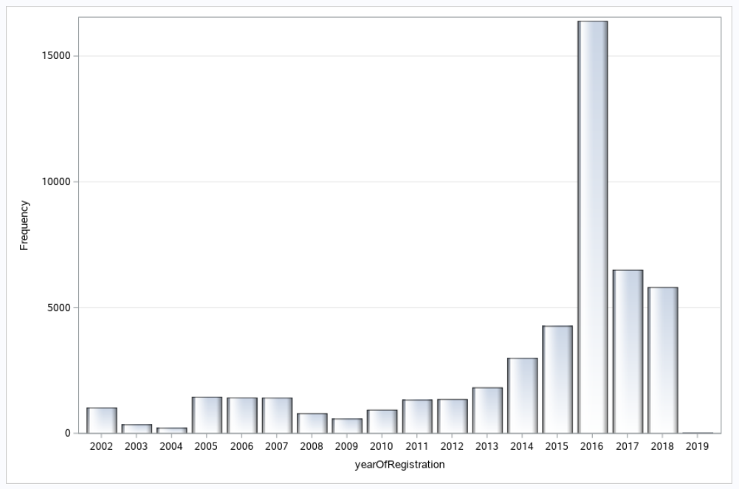

**Fig.1 Bar Graph of Every Year Registered Cases.**

Human traffickers were at risk of being captured by law authorities before the Internet because they advertised their victims on the streets. However, because sex merchants no longer need to advertise on the streets, the transition to the Internet has made it easier and less dangerous for them.

There is now a myriad of websites that host and provide sexual services under categories such as escort, adult entertainment, massage services, and so on, all of which assist sex vendors and customers keep their identities hidden.

From Fig. 1, we see that the number of Human Trafficking cases have drastically increased in the year 2016 reaching up to 15000 as compared to the year 2015 where there were around.4500 cases. The cases have slowly reduced by the year 2017 falling to a little higher than 5200 and have declined a bit more in the year 2019 falling further to a little more than 5000.

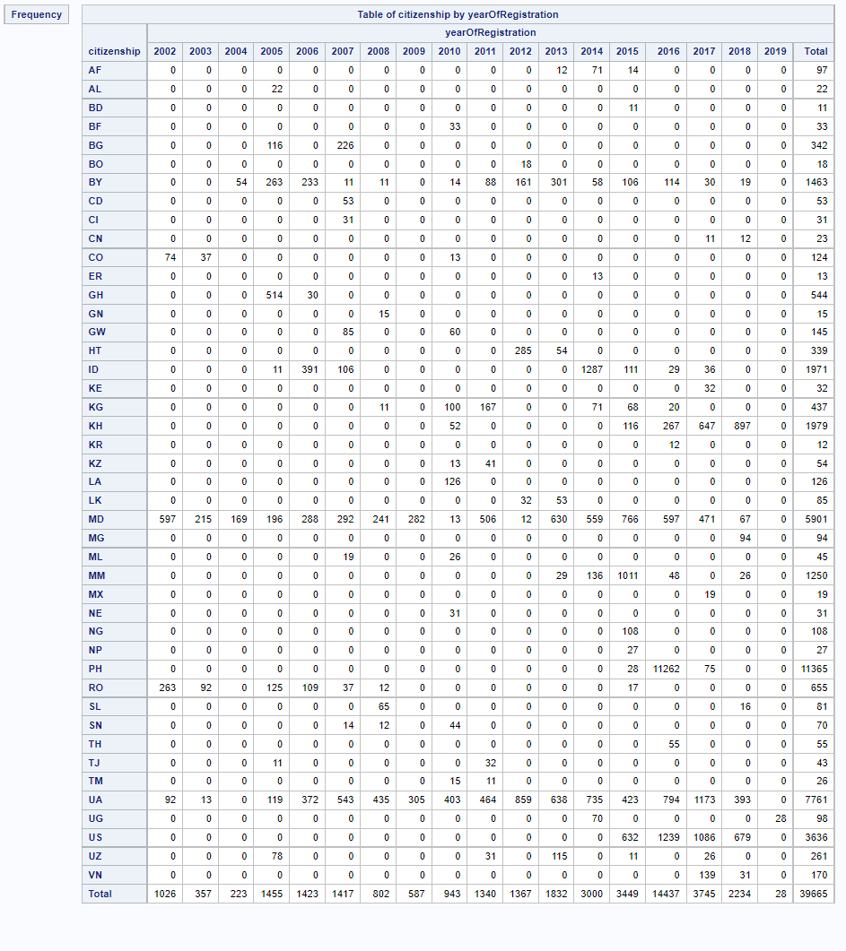

**Fig. 2 Table of Country wise Cases with Years**

In the country of Afghanistan cases have been registered in the the year 2013,2014 and 2015 total accounting to 97 cases and in the country of Albania cases have been registered only in the year 2006 and after that no cases have been registered which means that the act of human trafficking has reduced in the country. The highest number of cases has been registered in the country of Philippines where the maximum number of cases were registered in the year 2016. In the year 2019 cases have been registered only in the country of Uganda which was around 28 cases after the year 2014.

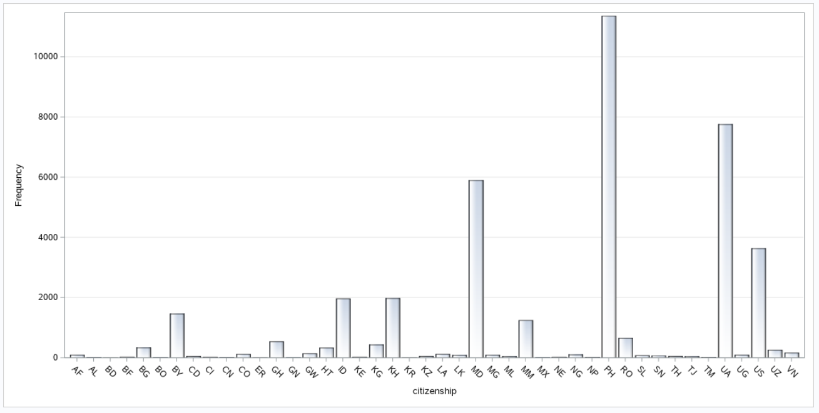

**Fig. 3 Bar Graph of cases with respect to countries.**

In the above list we see that the country Philippines has a frequency of 11365 which is the highest among all the other countries

In this above list we see the list of all the countries that have been taken into consideration for the purpose of analysing human trafficking conditions across them.

**Fig. 4 Bar Graph of Male and Female cases.**

In the above Bar Graph and the Pie Chart we make a comparison to find which gender has been affected most. In this comparison we see that women have been affected most by human trafficking compared to males. The number of women who have been prone to human trafficking is around 35,534 and the number of men is 13,267.

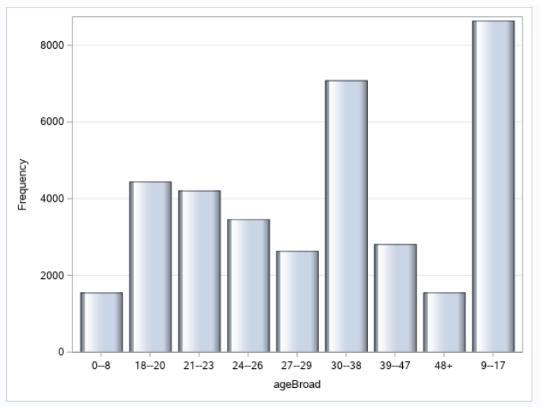

**Fig. 5 Bar Graph of Number of Cases with respect to Age Broad.**

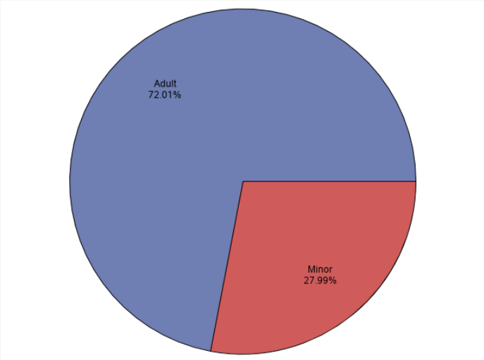

**Fig. 6 Pie Chart of Percentage of Adults and Minor.**

The above bar graph gives information about various age groups that have been affected. It shows that the age group of 9-17 has been affected the most by human trafficking.

The pie-chart tells us that 72.01% of adults have been affected mostly compared to minors where only 27.99% have been affected.

We have also done Cluster Analysis for this dataset. When we have done automatic clustering, we found the result set has 4 clusters with uneven distribution of variables which is shown in figure.

|  |  |
| --- | --- |
| https://lh4.googleusercontent.com/fMFyJNfwOH0WlQgFDZB5FIHlVPDLf-WF14diwY4DoI8Bgd31q9mIQrBYol4A9n6kABvqfKAi1ddrUZnTYlHk1DAjrblcGTG6PIW4bIvXYpr2Sy5iqQ9kX19kTSuCFeod8EWJUHaH | https://lh5.googleusercontent.com/ge409H1FYuj2f2bhn15NhAOu2uIexpBH8fnVaYK_pLSuVnpzpsR3iDqsV0_9PahERqSkwJvT2uq8h1WzcmICRvg44FOqn02fRFtl105xenKOEJvTxeG7YqbgjcxT597FyDMjLH22 |
| (a) | (b) |

**Fig. 6 (a) Number of Clusters using automatic clustering (b) User specify 2-clusters distribution.**

When we have done user specified clustering and gave the count as 2, we found even this method has uneven distribution of variables. So, we couldn’t analyse this data using cluster analysis.

**Conclusion:** So, from the above analysis, we can conclude that adults, especially females, between the age group of 9-17 are affected more by human trafficking and the country of Philippines has recorded the highest number of cases.

References:

1. Lu, J.Y., Chen, L.J., Kao, T.F., Chang, H.H., Chen, H.W., Liu, A.S., Chen, Y.C., Wu, R.B., Liu, W.S., Chyi, J.I. and Sun, C.K., 2006. Terahertz microchip for illicit drug detection. *IEEE photonics technology letters*, *18*(21), pp.2254-2256.
2. Sam, L.Z., bin Maarof, M.A., Selamat, A. and Shamsuddin, S.M., 2007, November. Features extraction for illicit web pages identifications using independent component analysis. In *2007 International Conference on Intelligent and Advanced Systems* (pp. 139-144). IEEE.
3. Sanfilippo, A. and Chikkagoudar, S., 2013, November. Automated detection of anomalous shipping manifests to identify illicit trade. In *2013 IEEE International Conference on Technologies for Homeland Security (HST)* (pp. 529-534). IEEE.
4. Pagsuyoin, S., Latayan, J. and Pagsuyoin, B., 2015, April. Understanding illicit drug use patterns through wastewater analysis. In *2015 Systems and Information Engineering Design Symposium* (pp. 300-305). IEEE.
5. Liao, J.Y., Huang, C.M. and Guo, J.L., 2015, April. A flash-based animation program of illicit drug prevention for high-risk adolescents: A flash-based animation program of illicit drug prevention. In *2015 International Conference on Learning and Teaching in Computing and Engineering* (pp. 204-206). IEEE.
6. Ding, T., Roy, A., Chen, Z., Zhu, Q. and Pan, S., 2016, December. Analyzing and retrieving illicit drug-related posts from social media. In *2016 IEEE International Conference on Bioinformatics and Biomedicine (BIBM)* (pp. 1555-1560). IEEE.
7. Zhou, Y., Sani, N. and Luo, J., 2016, December. Fine-grained mining of illicit drug use patterns using social multimedia data from Instagram. In *2016 IEEE International Conference on Big Data (Big Data)* (pp. 1921-1930). IEEE.
8. Wang, J., He, S., Xu, Y., Cao, Z., Wang, L. and Zeng, D.D., 2016, September. Spatial-temporal patterns and drivers of illicit tobacco trade in Changsha county, China. In *2016 IEEE Conference on Intelligence and Security Informatics (ISI)* (pp. 127-132). IEEE.
9. Gupta, S. and Shrimali, M., 2016, February. Secure Data Transmission over Illicit Network. In *2016 Second International Conference on Computational Intelligence & Communication Technology (CICT)* (pp. 298-301). IEEE.
10. Kejriwal, M., Szekely, P. and Knoblock, C., 2018. Investigative knowledge discovery for combating illicit activities. *IEEE Intelligent Systems*, *33*(1), pp.53-63.
11. Torres, E., Granizo, S.L. and Hernandez-Alvarez, M., 2019, December. Gender and age classification based on human features to detect illicit activity in suspicious sites. In *2019 International Conference on Computational Science and Computational Intelligence (CSCI)* (pp. 416-419). IEEE.
12. https://www.kaggle.com/andrewmvd/global-human-trafficking.